Connecting to Teams for your online interview
You may receive an invitation to one or more interviews and will receive a separate invitation email for each interview. Your Microsoft Teams meeting invitation should look something like this:
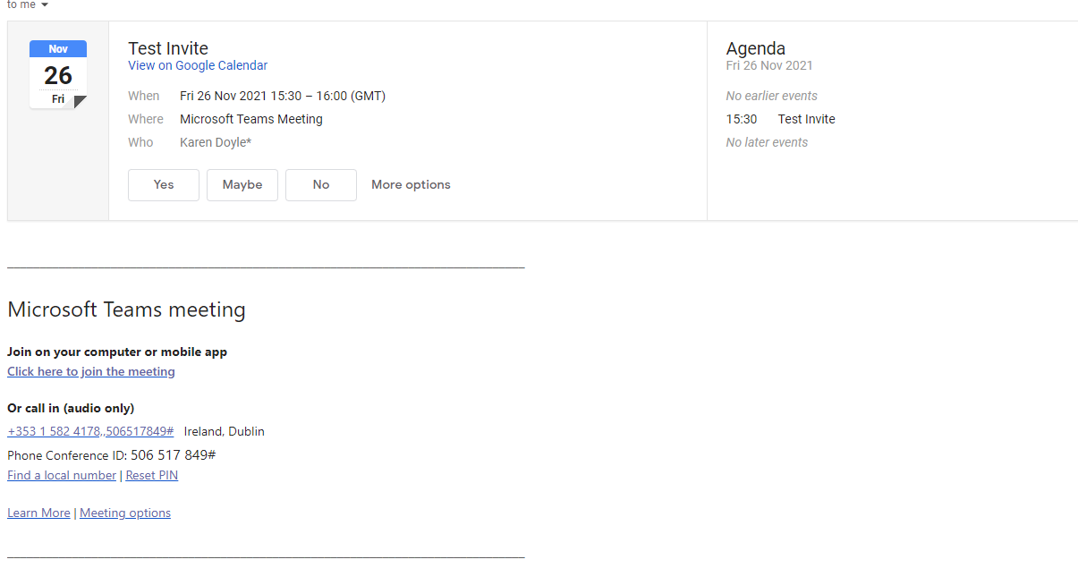

You don’t need to have Microsoft Teams installed provided that you have a browser that is capable of joining Microsoft Teams video calls. Google Chrome and Microsoft Edge are the recommended browsers for Microsoft Teams, but full details can be found on the Microsoft website.
Note: Safari is not recommended for use when joining Teams via a browser.
Shortly before the start of your interview, you should open your invitation email and click the ‘Click here to join the meeting’ link at the bottom of it.

You may get a message asking if you want to open Microsoft Teams:
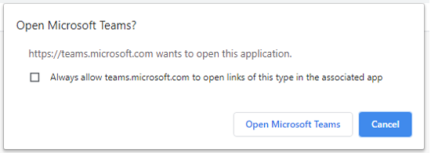
If you have Microsoft Teams installed and are able to use it, then you can select ‘Open Microsoft Teams’. Otherwise, select ‘Cancel’.
If you aren’t using the Teams application, then you will see some options in your browser like those below:
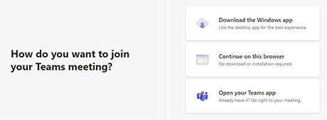
In order to join the interview, click ‘Continue on this browser’. If you don’t see the ‘Continue on this browser’ option then you might not be using a compatible browser, and we’d suggest downloading the application.
Before you join, you’ll be able to change your microphone and webcam settings (if they are correct you should be able to see yourself), and, unless you are already logged in to an existing Teams account, you’ll be able to change your name (just use your actual name!):
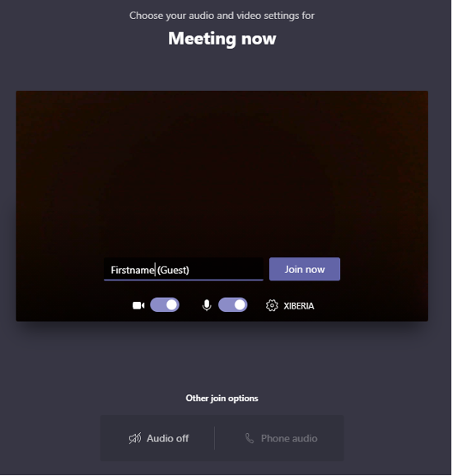
Once you are ready, click ‘Join now’ to enter the virtual lobby. You should see a message like this until the interviewers admit you to the interview call:
When you are in the interview if you move your mouse around, you should see a toolbar allowing you to turn your video and/or audio on or off using the camera and microphone options. Unless told otherwise, you should have your video and audio switched on. Note, if you are using the Teams app (so not accessing via a browser) and select the option to blur your background, any paper workings you hold up to the webcam will also be blurred and not visible to your interviewers, so we recommend that you do not do this.
To leave the call at the end of the interview, press the red phone button to hang up.

