Online Interview Guide

Table of Contents
Interview and Online Invitation 1
Technical Issue Notice 3
Technical Backup Plan 4
Preparing for your Online Interview 4

Interview and Online Invitation
All Training Programme candidate interviews for RCPI programmes are currently held online via Microsoft Teams.
- To participate in an interview, you will receive an MS Teams calendar invitation through email similar to the one below.
- It states the date and time of the interview.

- Click on Yes to accept the Interview Invitation.
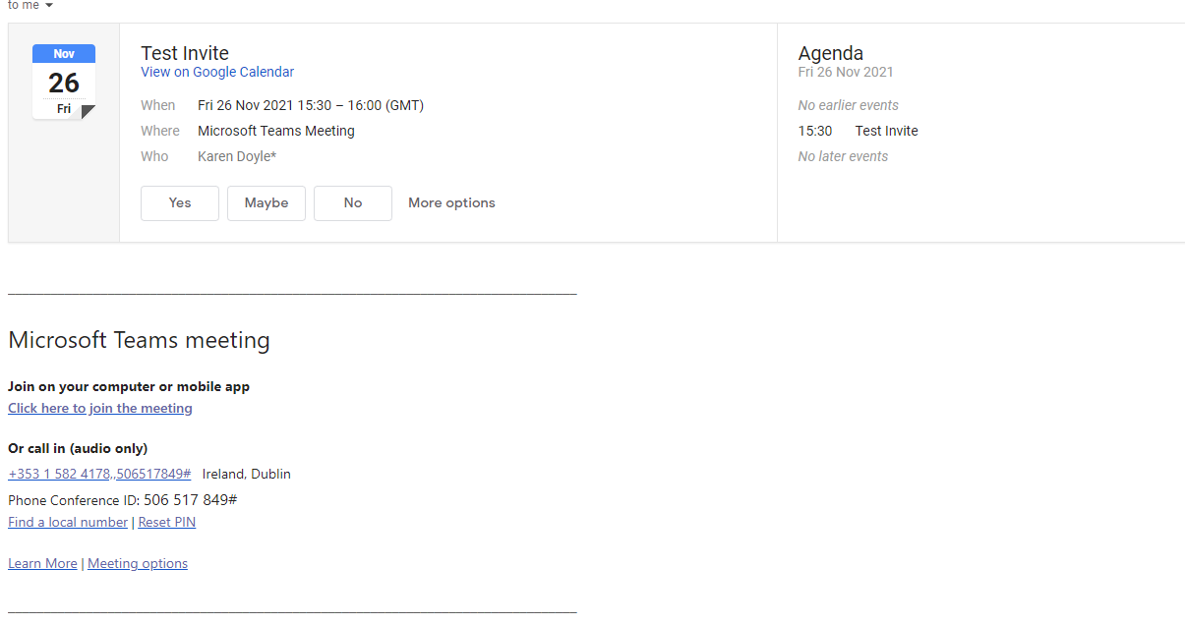
- On the day and time of the interview, please access the email you received and click on the link: Join
Microsoft Teams Meeting. If you cannot find the email invitation, look in your email account calendar.
- To use MS Teams, you can run it through a browser or the MS Teams application. When you select Join Microsoft Teams Meeting, the following screen appears.
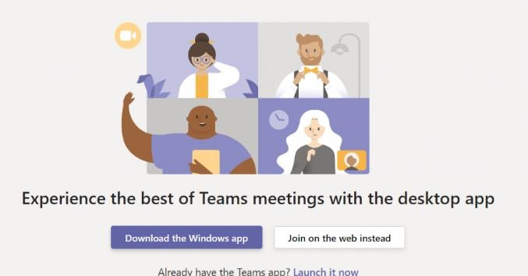
- If you are familiar with the MS Teams application, select Launch it now. Otherwise, please select the button Join on the web instead. Please note that the preferred browsers are Microsoft Edge and Google Chrome.

- You can then run the meeting through the browser. The below screenshot shows how the browser appears after clicking on Join on the web instead.
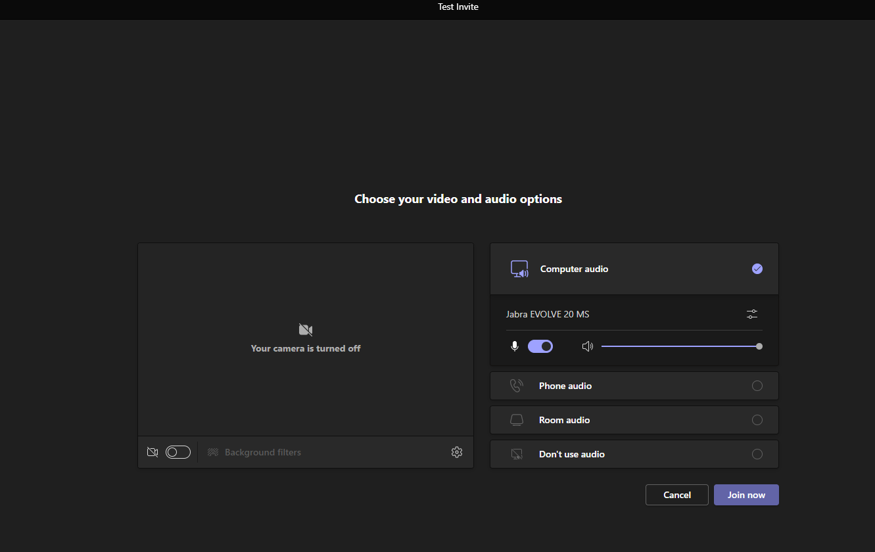
position.
- Click on the Join Now button.
- You enter into the meeting room lobby, and from here, the interviewers Admit you into the meeting.
- The interview commences at this point.

Technical Issue Notice
- Please join the meeting on time to problem solve and ensure the quality of the connection.
- Please note that should there be a connection failure before or during the interview, 3 attempts are made to reestablish a connection.
- If issues occur, please click on the link again in the email Join Microsoft Teams Meeting and go through steps 4 to 10 above.
- Please have your phone close by in case you or your interviewer might be having technical difficulties and they are trying to contact you via phone or email

Technical Backup Plan
- If the connection cannot be re-established, for whatever reason, in the email invitation you received, you will see a Dublin (Toll) number and a conference ID, similar to the screenshot below:
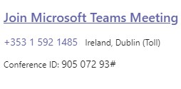
- If after 3 attempts you cannot connect, dial the telephone number followed by the conference id and the # symbol when requested. This will get you back into the interview.

Preparing for your Online Interview
- Confirm that your webcam and microphone are suitable and work correctly in your chosen browser (Google Chrome or Microsoft Edge) or the MS Teams application. Both need to work as the interviews need to see and hear all applicants.
- If you are using a laptop or tablet, please ensure to charge fully.
- Test your internet connection to ensure it is reliable and working.
- If using headphones, make sure they are connected and working before the interview.
- We recommend a test call is carried out in the lead up to the interview to test your connectivity. Microsoft Teams is available for free if you wish to check the technology: MS Teams Free Edition
- If possible, conduct your interview in a quiet area that is free from distractions.
- Again, keep your mobile phone close by if for any reason you need to be contacted or you might be having technical difficulties.
- Please join the meeting on time to problem solve and ensure the quality of the connection.

